Event Management for Microsoft Dynamics AX

Table of Contents

Introduction 4

Overview 5

Process Visual Representation 7

Data Flow Diagram 7

Social Media Setup 8

Outlook Setup 10

Workflow Setup 11

Event type group setup 12

Event types setup 13

Editable attributes setup 14

Food preferences setup 15

Pick up drop locations setup 16

Allergies setup 17

Event details list page 18

Event planning & creation 18

General 19

Venue 20

Event Preferences 21

Event Invitations & tracking 22

Invite employees 22

Outlook & Workflow invitations 22

Workflow invitations & employee response 27

Attendees information & invitation tracking 29

Facebook & Twitter Posts 30

Employee list page 32

Employee surround details 33

Employee family details 33

Roles & Security 34

Event manager 34

Employee 34

Highlighted Features

|  |  |
| --- | --- |
| Features | Purpose |
| Global Address Book | Shares the full address details of employee and event entities like Pick up drop locations and venue |
| Workflow | Event approval and event invitations within Dynamics AX using Workflows |
| Outlook | Workflow work items as outlook voting mails, invitation as Calendar invites, confirmation mails etc. |
| Social Media | Facebook and twitter posts with images and videos |
| Maps | Google and Bing maps for Venue details |
| Enterprise portal | Eliminates the dependency of AX client with useful features on Enterprise Portal as well |
| Setup facilities | Parameters, attributes etc. can be set up once forever and can be overridden at any level |
| Rich GUI | Provides different details of employees, events, invitations etc. in rich GUI interfaces such as forms, dialogues etc. |

Process and Design Overview

## Introduction

**Event management** is the application of [project management](http://en.wikipedia.org/wiki/Project_management) to the creation and development of large scale events such as [festivals](http://en.wikipedia.org/wiki/Festival), conferences, ceremonies, formal parties, concerts, or [conventions](http://en.wikipedia.org/wiki/Convention_(meeting)). It involves studying the brand, identifying the [target audience](http://en.wikipedia.org/wiki/Target_audience), devising the event concept, planning the logistics and coordinating the technical aspects before actually launching the event.

Currently, in Dynamics AX there is no such standard application to achieve the above task. However, the project management module can serve the purpose to some extent but would not be decisive enough as powerful marketing and communication tools provided by our **Event management module**.

With the new **Event Management for AX**, the company can broaden their horizons and can reach out to more and more people cordially and effectively. Integration with social media, outlook and workflows allows the event manager to communicate to large number of people and generate media coverage.

## 

## Overview

The diagram shown, depicts how the event management integrates itself with existing employee module for the effective management of both. The major components are as follows:

1. **Event management**
   1. Event categorizations (Corporate/ Family)
   2. Event preferences (food preferences and pick up drop location preferences)
   3. Event invitations
   4. Event parameters
   5. Outlook and workflow integration
   6. Social media integration(Facebook and twitter)
   7. Event planning and tracking
   8. Venue address with Maps
   9. Reports
2. **Employee Management**
   1. Family details and their preferences
   2. Employee preferences (food preferences and pick up drop location preferences)
   3. Event invites and responses
   4. Outlook and workflow invitations
   5. Roles & privileges

## Process Visual Representation

## Data Flow Diagram

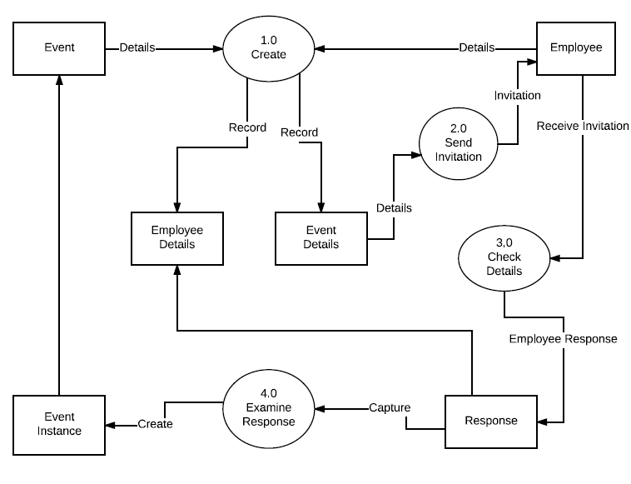

Setting up the integrated tools

## Social Media Setup

Area page node: Event Management -> Setup -> Event management setup parameters -> Social media

You must setup the facebook and twitter parameters to allow the posting of events. This diagram shows the initial setup for social media parameters.

When you create your app on facebook and twitter, you get these Application/Secret Key for facebook and Consumer key/secret for twitter. That information should be provided on this form.

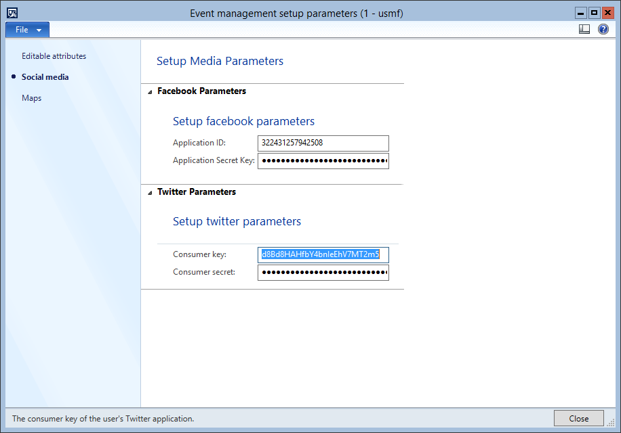

Area page node: Event Management -> Setup -> Link social media

Next diagram shows the form which require details for authentication. Once you provide the necessary details on this form, it will retrieve the access tokens that will be used to post to facebook and twitter. It makes calls to open graph API and twitter API for facebook and twitter respectively.

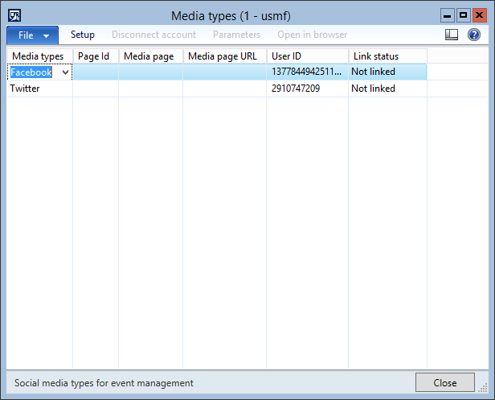

## Outlook Setup

Area page node: **System administration -> System -> Email parameters**

You must set up the email parameters before availing the outlook services. The form shown here is the standard email parameters form which consists of a group wherein you can provide exchange service account information such as Office365 etc with the smtp server and authentication details.

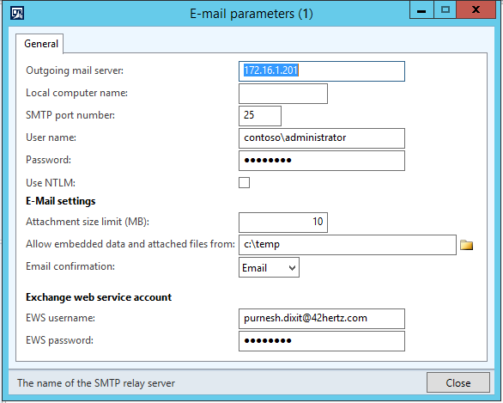

## Workflow Setup

Area page node: Event Management -> Setup -> Event management workflows

You must set up the workflow for event approval and event invitation for the smooth functioning of Event invitation within dynamics AX and outlook & workflow integration. The form shown contains the two workflows for event approval and event response respectively. These can be customized based on requirements in the workflow editor.

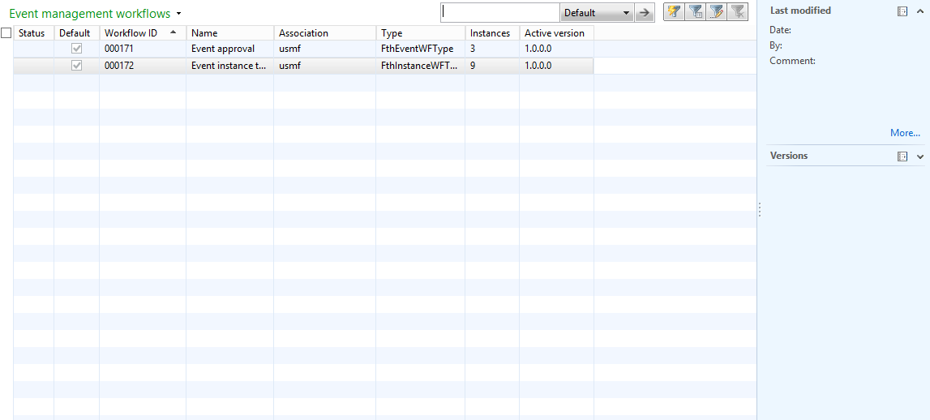

Setting up Event Parameters

## Event type group setup

Area page node: Event Management -> Setup -> Events -> Event type groups

You must setup event type groups for event where in you can specify whether the event comes under family or corporate category.

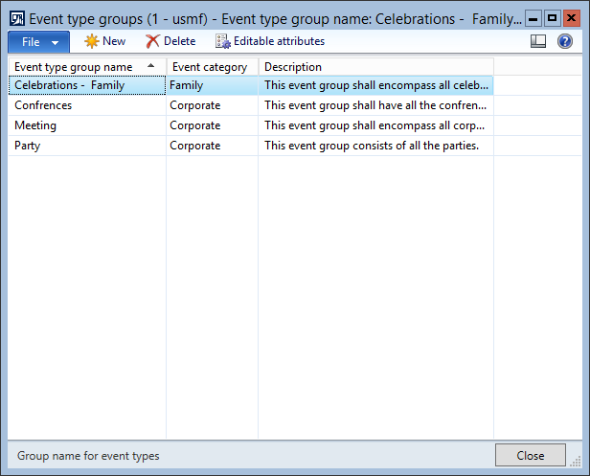

## Event types setup

Area page node: Event Management -> Setup -> Events -> Event types

You must setup event types which extends the event type group and provides a hierarchical functionality for grouping of events.

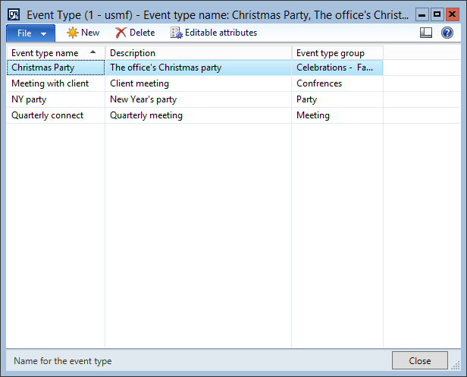

## Editable attributes setup

This is an interesting aspect. The form shown below serves the purpose of allowing changes in the attributes of any event after the submission for approval or publish event. You can simply mark the attributes which you want to allow to edit else the unmarked attributes wouldn’t be allowed to change unless the event is recalled or in draft mode. This form is accessible in event management parameter which marks the top level and can be overridden at each level i.e event type groups and event types etc.

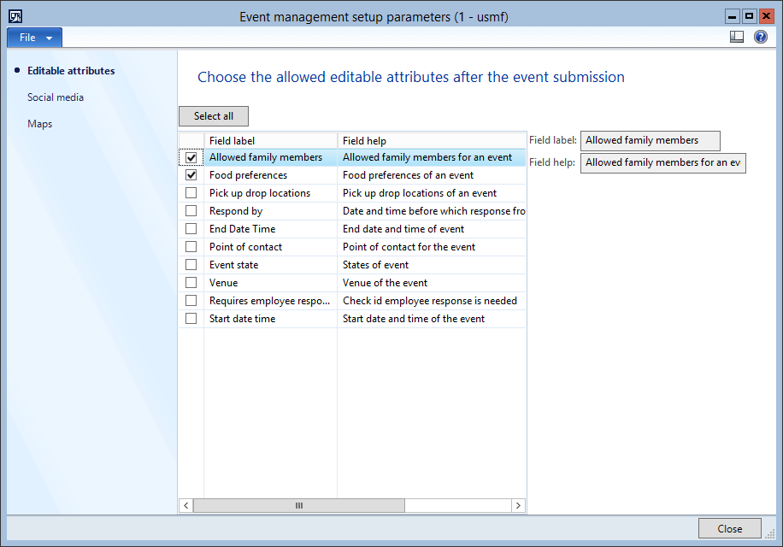

Setting up Event Preferences

## Food preferences setup

Area page node: Event Management -> Setup -> Preferences -> Food preference

You must setup the food preferences which can be taken as food preferences of any event. This form allows you to create food preferences.

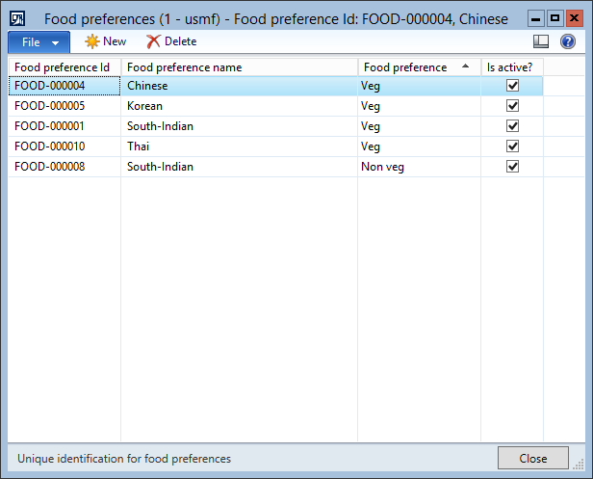

## Pick up drop locations setup

Area page node: Event Management -> Setup -> Preferences -> Pickupdrop locations

You must setup the pick up drop locations which can be taken as pick up drop locations of any event. This form allows you to create pick up drop locations.

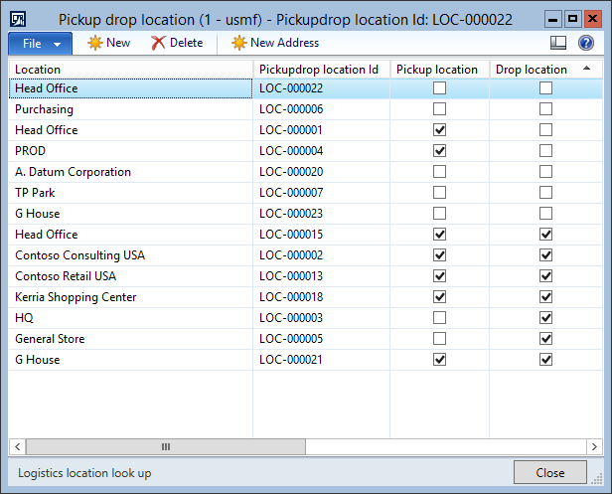

## Allergies setup

Area Page node: Event Management -> Setup -> Preferences -> Allergies.

This form allows you to create common types of allergies which can be shared between employees and events and allows the employee to accept invitation or not based on allergies.

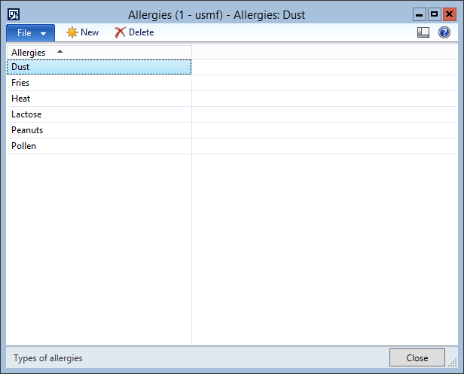

Event management

## Event details list page

Area Page node: Event Management -> Common -> Events -> Event details.

This is the list page and also the first page of event details. It displays the information about the created events. It consists of grid, preview panes, fact boxes, action pane etc. for detail descriptions.

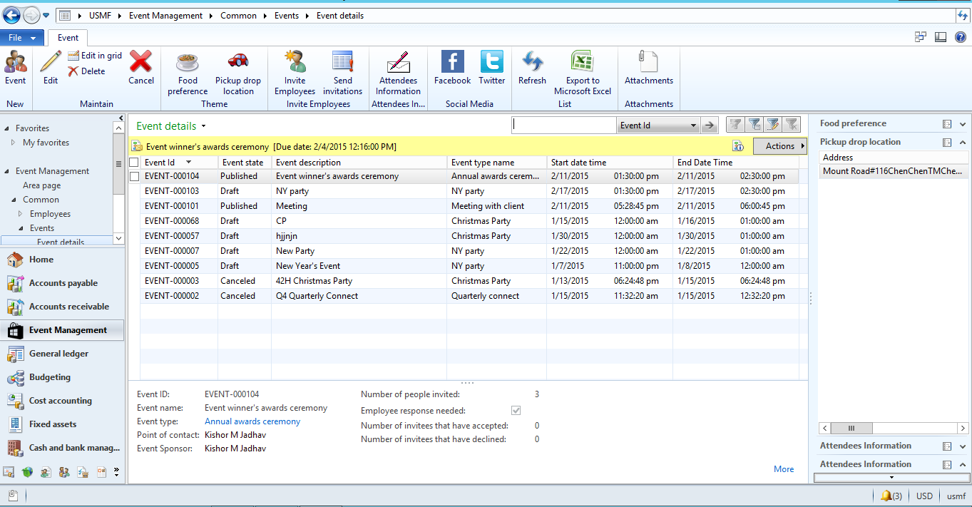

## Event planning & creation

This functionality provides the detail form master for creating events, filling up details, posting events etc. This form opens up by navigating to a particular event from the list of events on list page or when creating a new event. It consists of three tabs:

1. General
2. Venue
3. Event preferences

### General

In this tab the general information about the event should be filled in like description, start time, end time, invitation details etc.

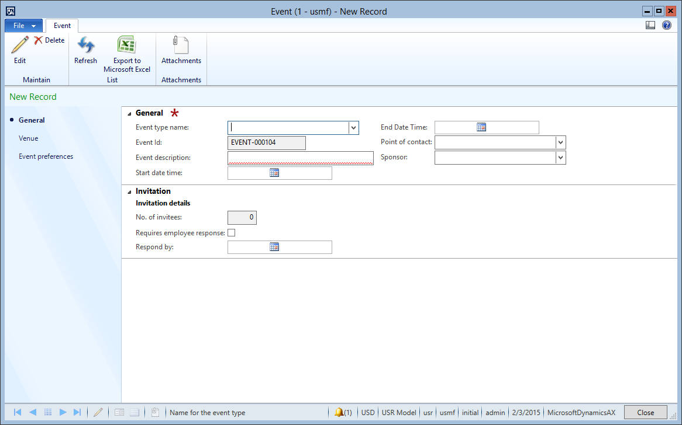

### Venue

In this tab, address for the event venue is created. Here, the address is created using Global Address Book standard interface or the existing address also can be chosen for the venue. Static image of the map of venue address is shown everytime the address is created or chosen to give a detailed view to you. You can also navigate to the map using browser for further directions of the venue.

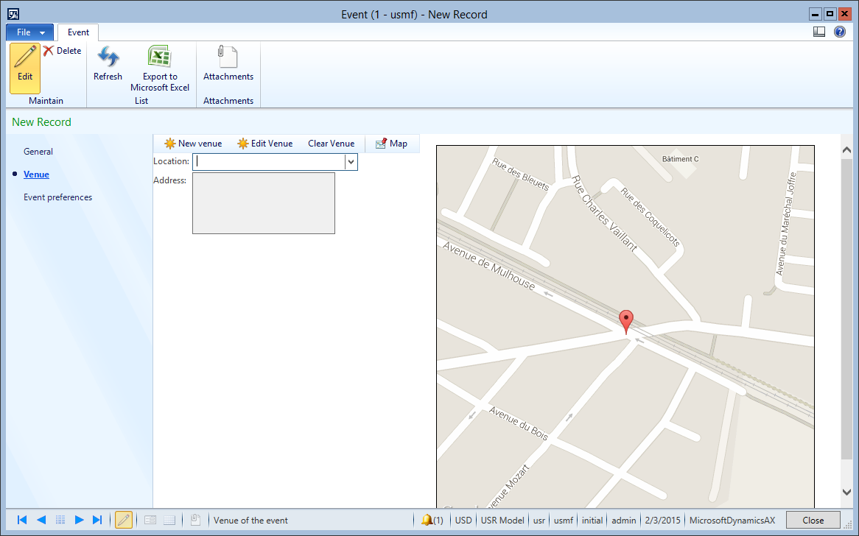

### Event Preferences

As the name suggests in this tab, you define the event preferences i.e. food preferences, pick up drop locations and allergies which are part of the created event. These details can also be viewed on the list page under respective factboxes.

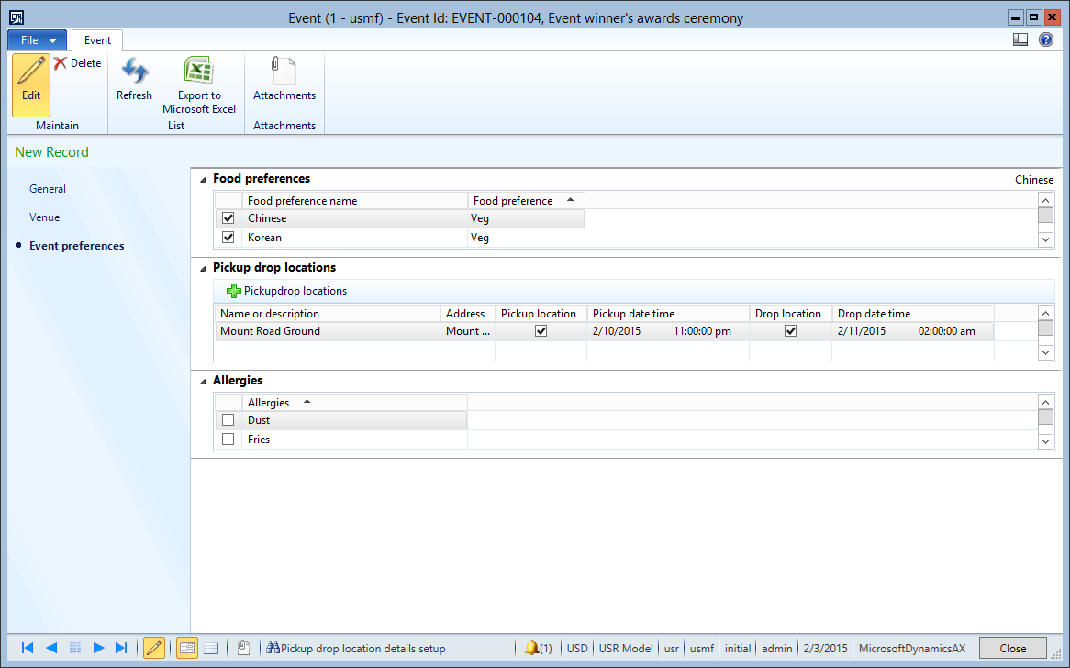

## Event Invitations & tracking

This functionality comes into picture once the event is drafted along with all the details as mentioned before. Major components of this functionality are as follows:

1. Invite employees
2. Outlook and workflow invitations
3. Tracking invitations
4. Employee responses
5. Attendees information
6. Facebook and twitter posts

### Invite employees

This form allows you to invite employees to a particular event. You can assign or remove employees easily to events.

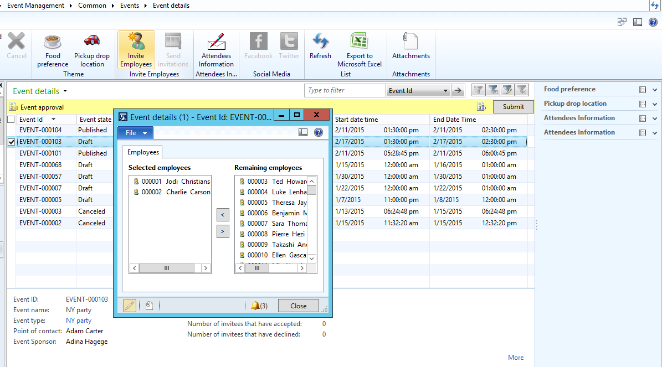

### Outlook & Workflow invitations

This is very useful functionality as it does not require any interface as such. Both of these runs in batches with required recurrences.

#### Outlook workflow processing

So, whenever the event is created and submitted for approval the outlook workflow processing batch sends the voting mail with allowed options for approval to the assigned user over outlook. And similarly, whenever any work item is assigned it sends the mail to the assigned user. This functionality does not restrict itself to only to event management but can be used all over.

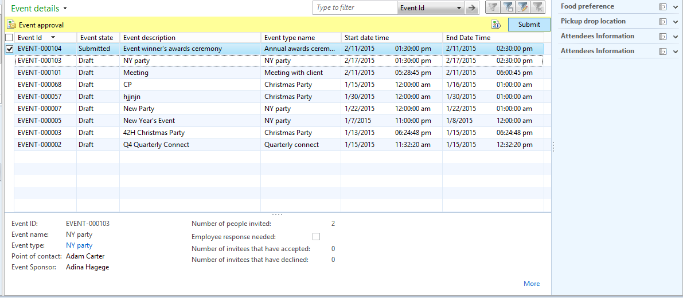

Submission for approval

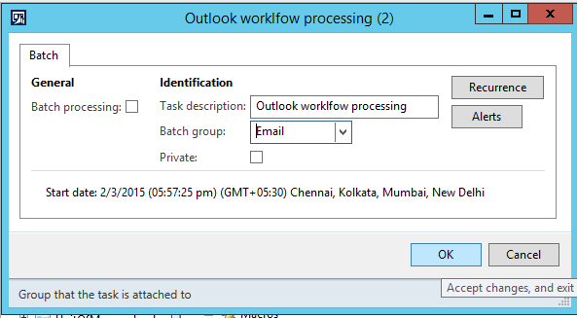

Outlook workflow processing batch

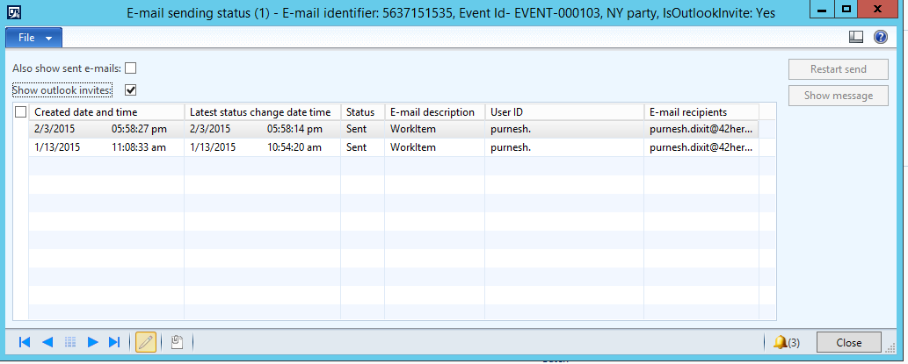

Work item sent over outlook

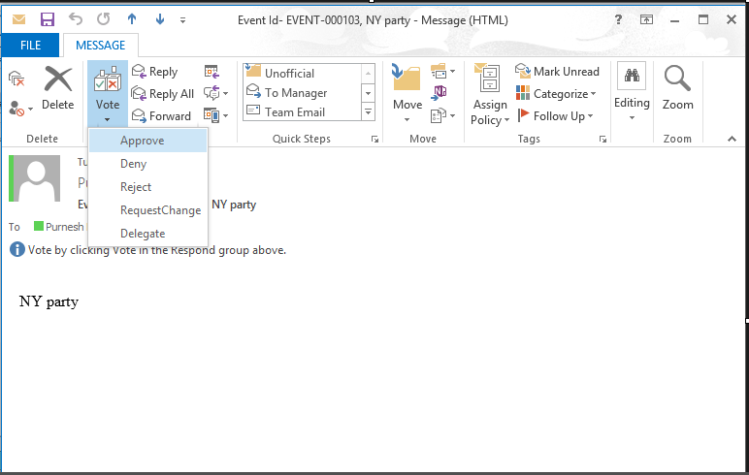

Work item email

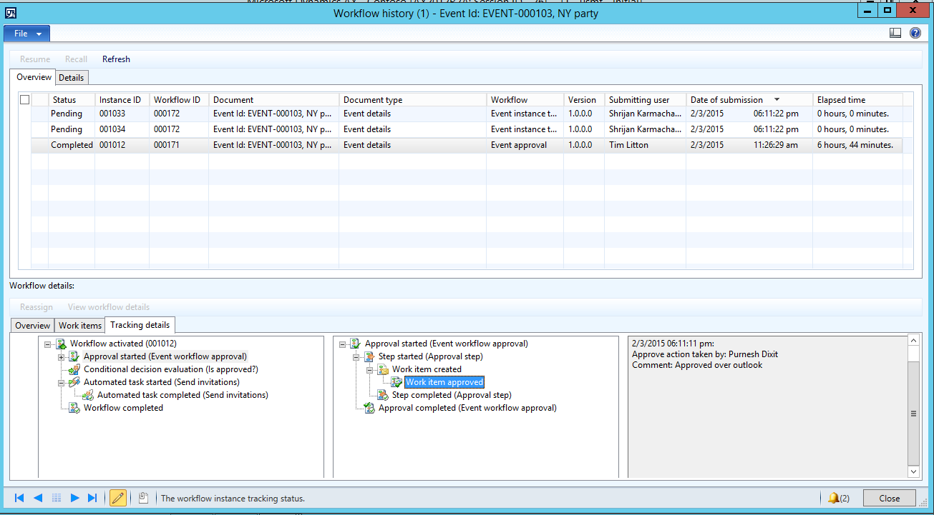

Workflow history of the approved work item over outlook

#### Outlook calendar invitations

This happens once the event is published. The outlook invitation processing batch takes care of it. Once the event is published a calendar invite is sent to all the invited employees.

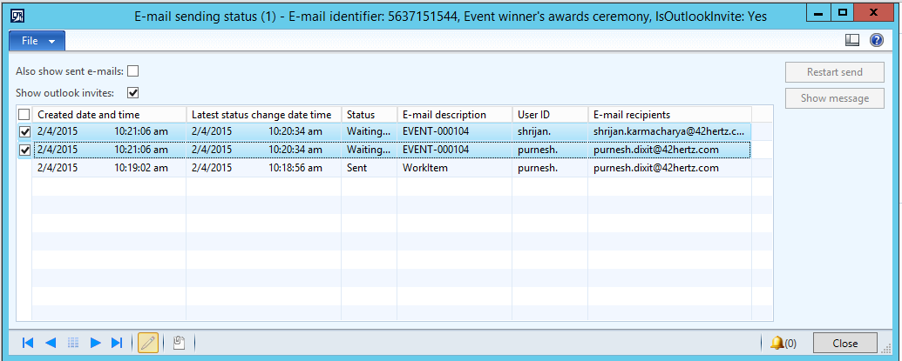

Invitation is in waiting state for the invited employees

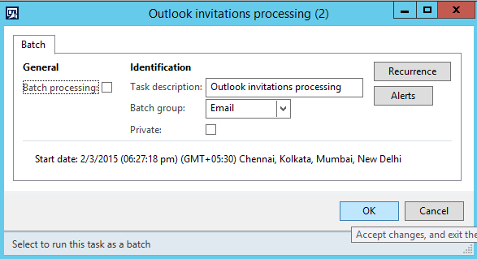

Outlook invitation processing batch

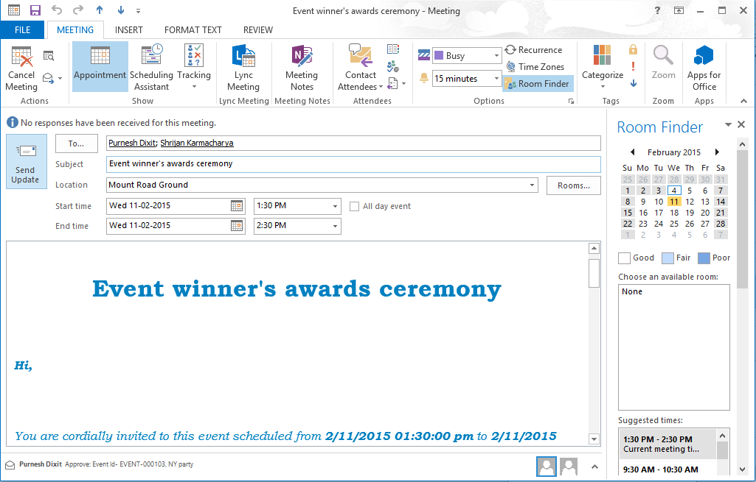

Calendar invite for the event

### Workflow invitations & employee response

Along with the outlook invitations and mails, workflow invite will also be sent to all the invitees within AX client and Enterprise portal. Once the employee accepts the invitation, he/she will be redirected to another form for filling out their responses.

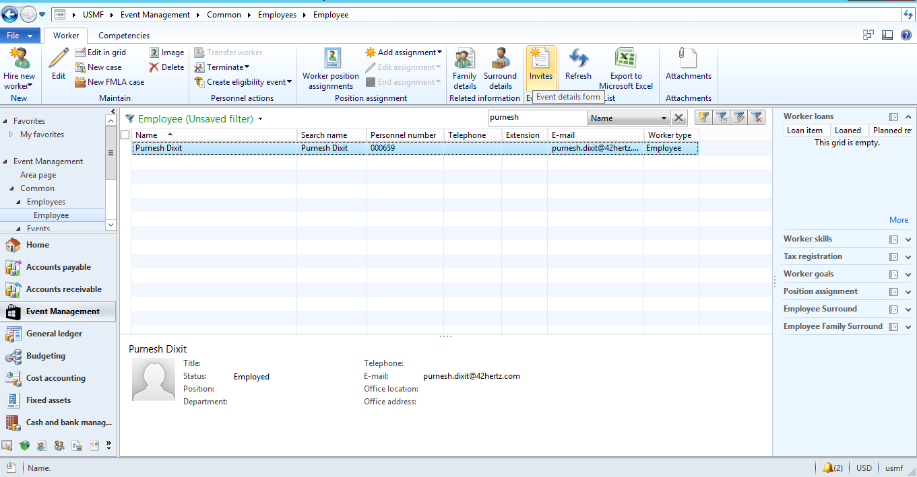

Standard employee list page with an option for seeing all the invites

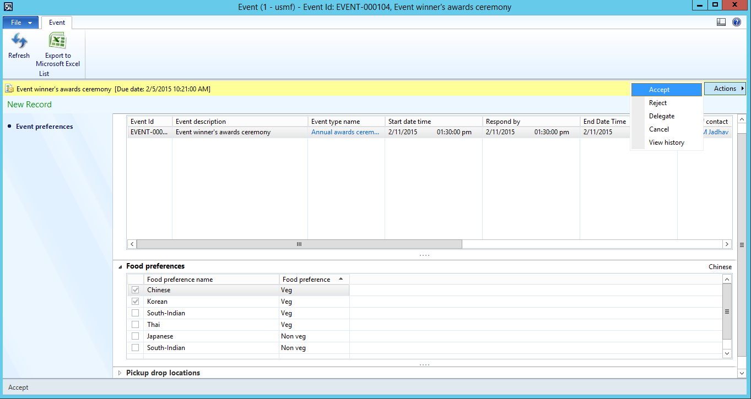

List of event invitation and their details with workflow response button for each upcoming events

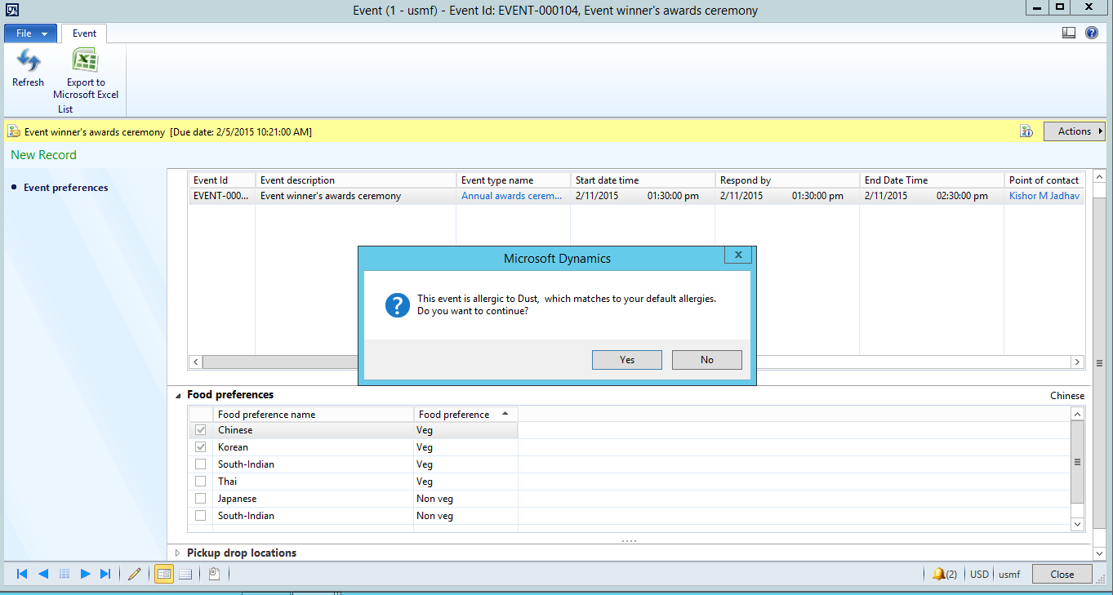

Warning in case of acceptance, if the employee and event share same allergies

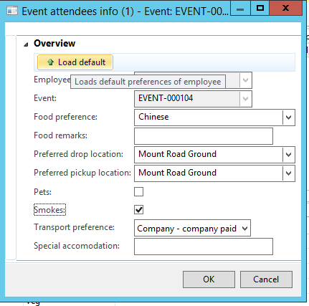

Response form for the employee

### Attendees information & invitation tracking

This Form provides all the information about attendees in a rich GUI. This gives clear details of employees’ responses and their asked preferences. This will majorly help in deciding budget and arrangement of actual event

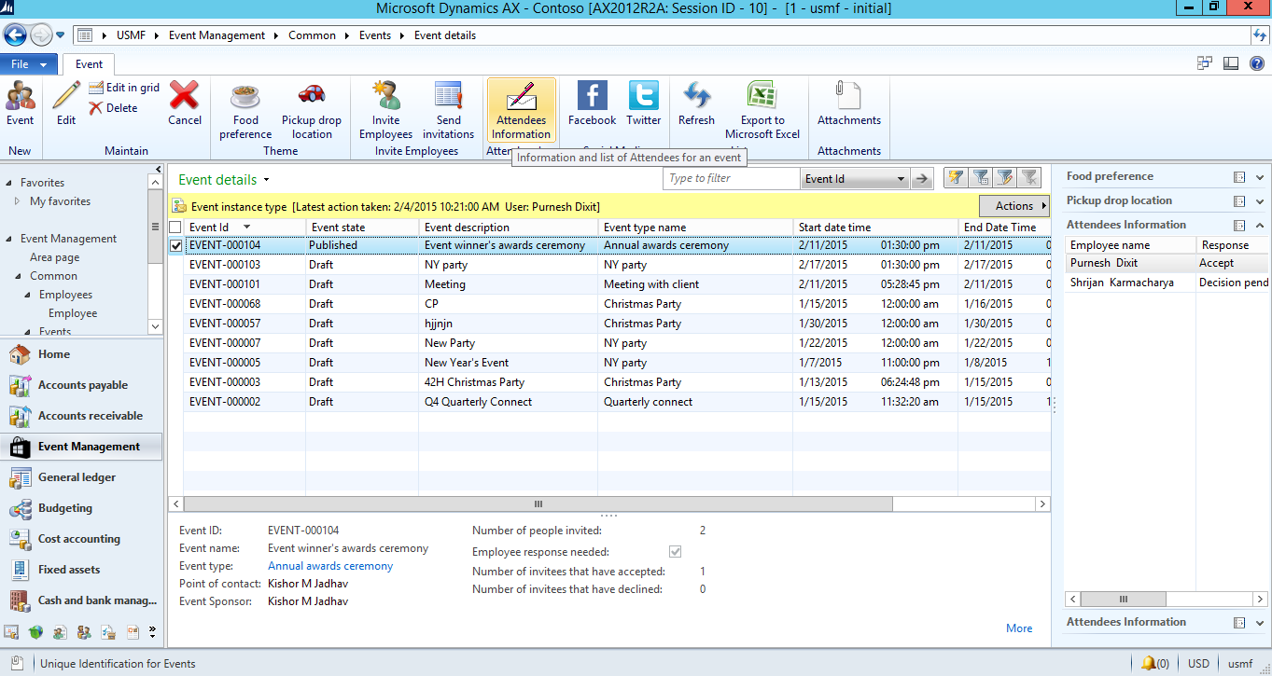

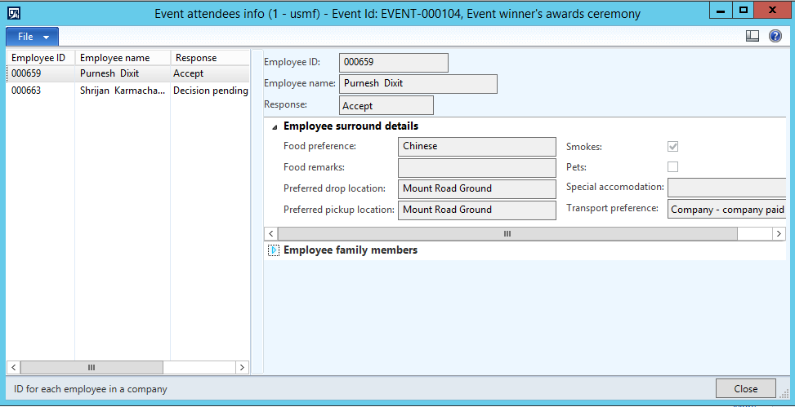

### Facebook & Twitter Posts

Once the event is published, the information about them can be posted over facebook and twitter from the AX client very easily. This would in turn helps to reach out more and more people. Moreover, mages & videos can also be uploaded with the post to make your post more appealing.

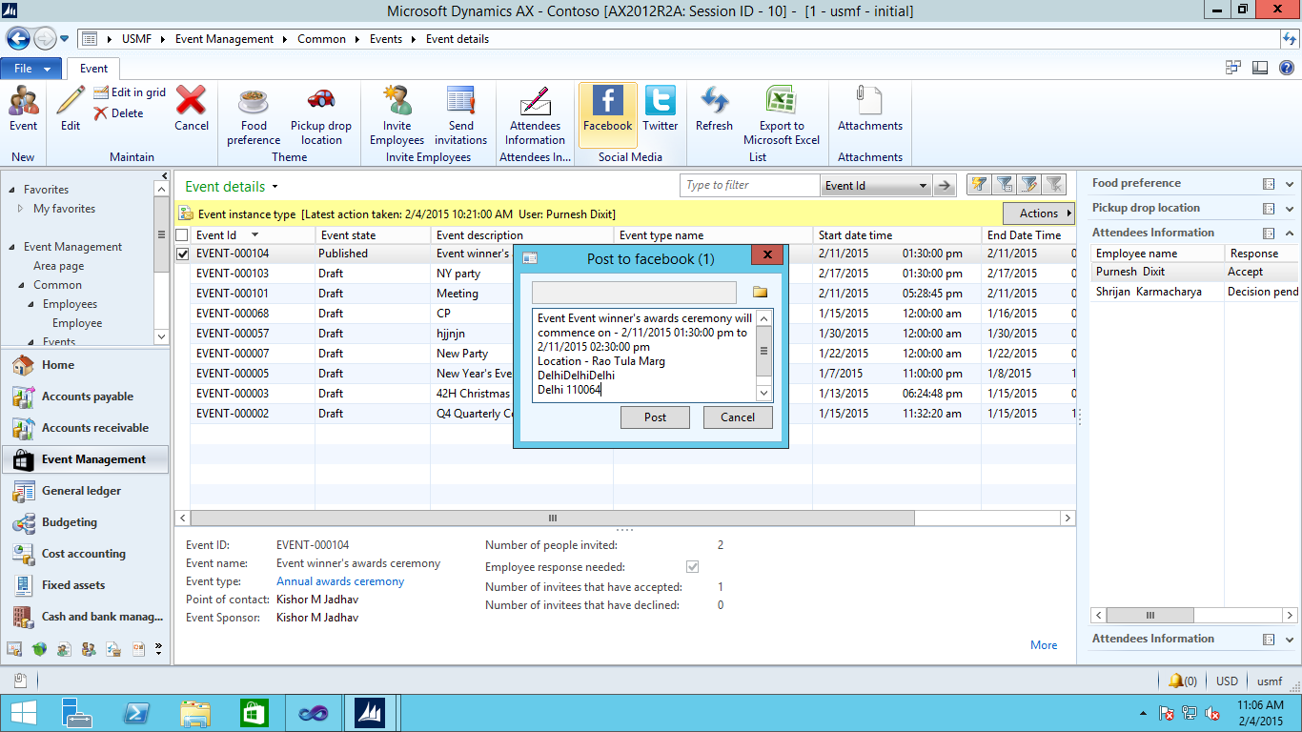

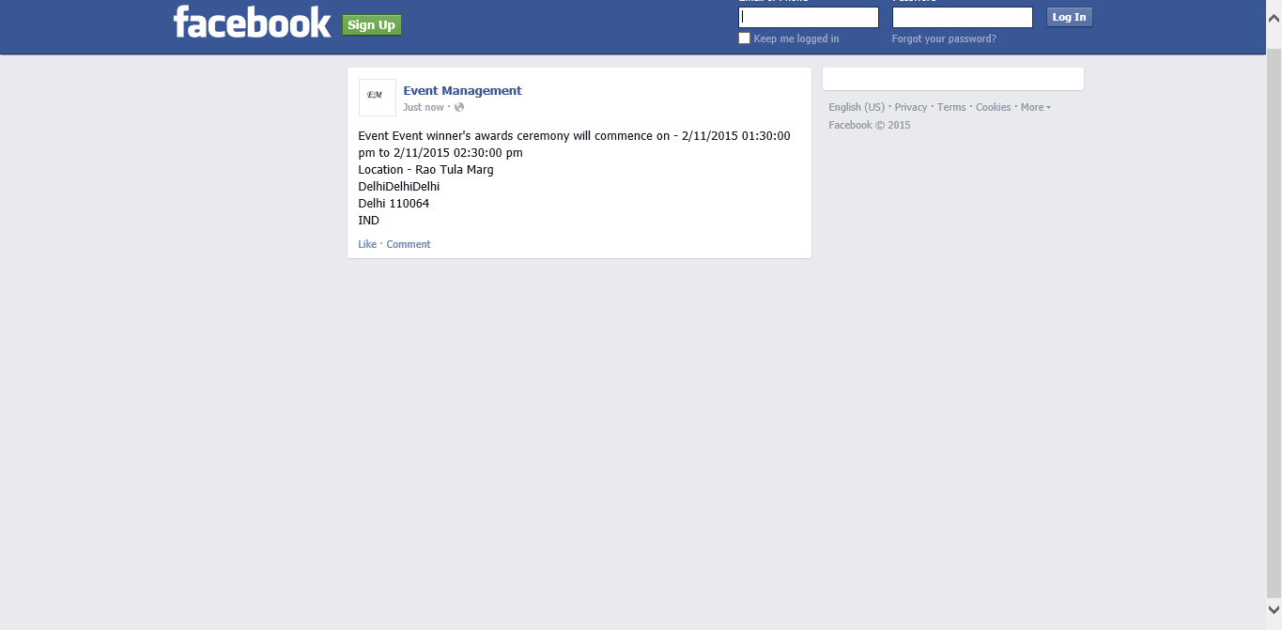

Facebook post

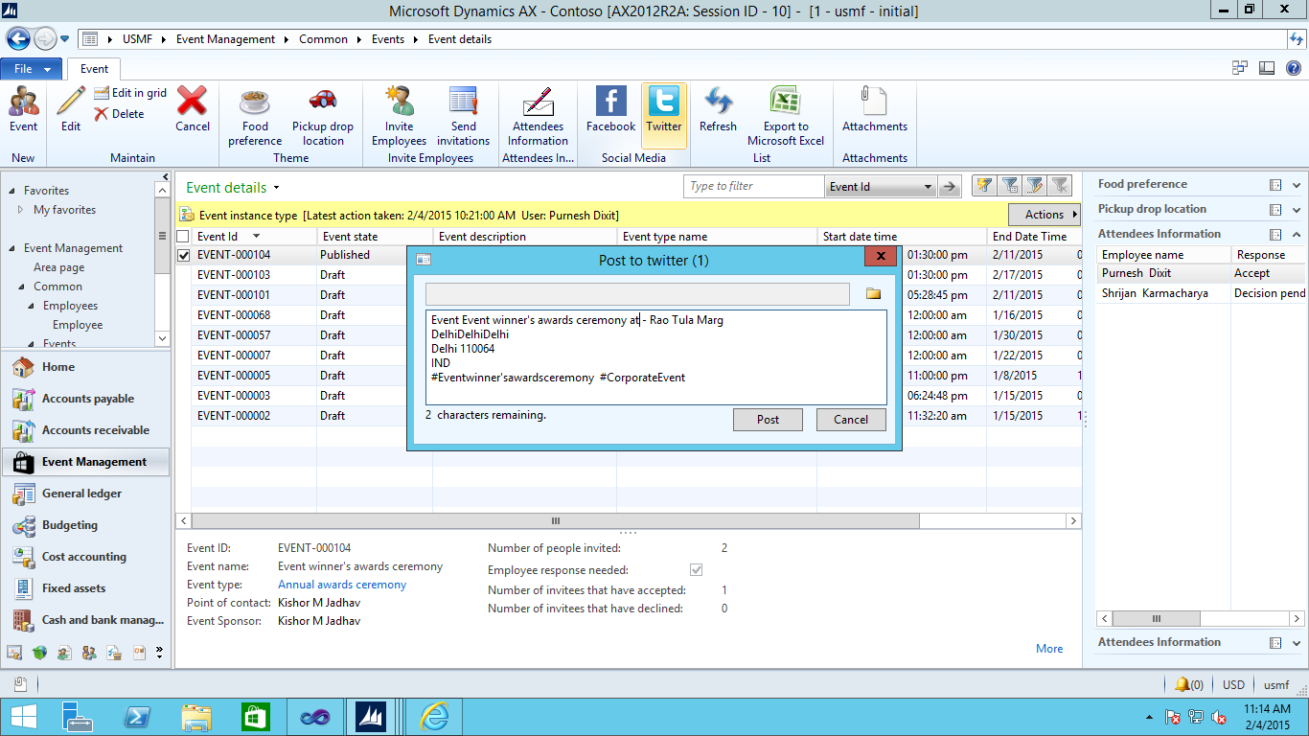

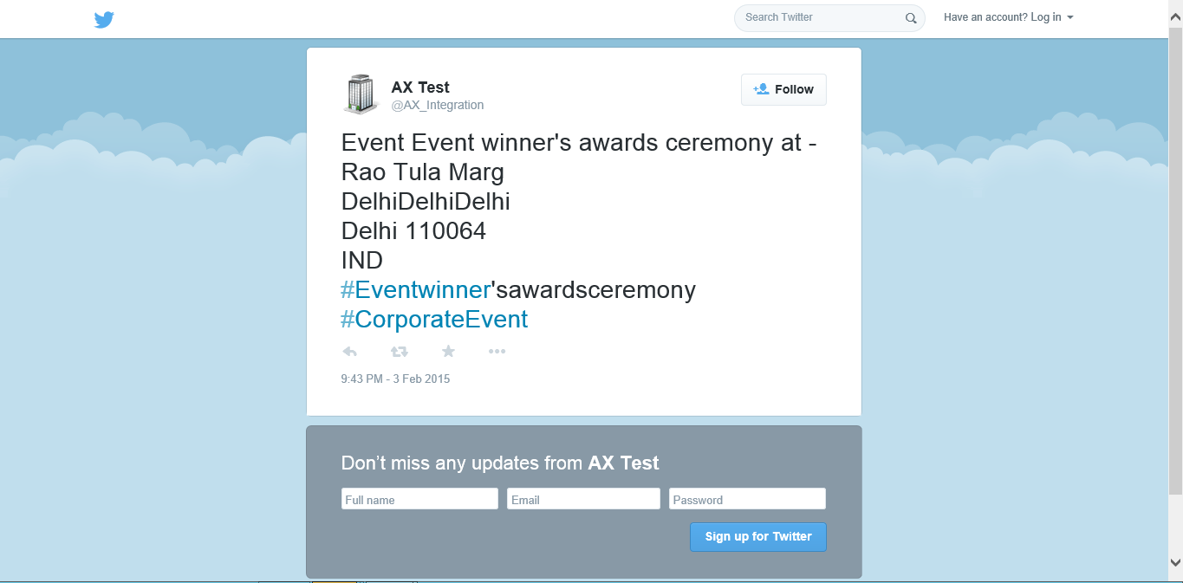

Twitter post

Employee management

## Employee list page

Area Page node: Event Management -> Common -> Events -> Employee

This is the standard list page of employee in HR module with few modifications related to Event management. It consists of few extra details like employee family, surround details and upcoming invites.

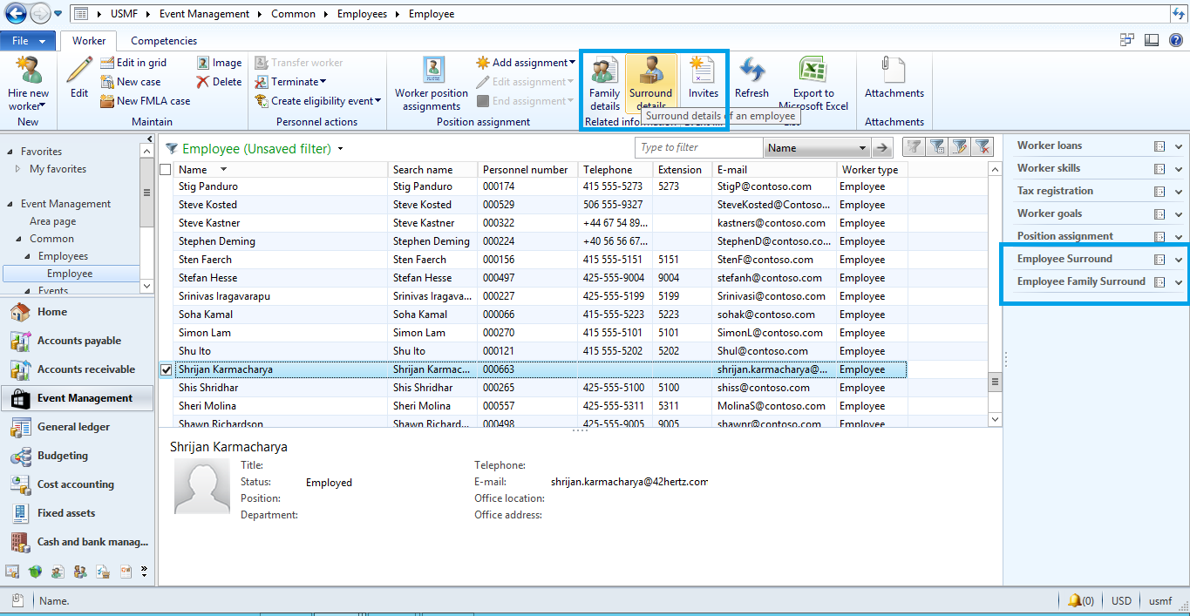

## Employee surround details

This is again a one-time setup for the employee. Here you should enter all the preferences of the employee so that they can be utilized for sending relevant invitations.

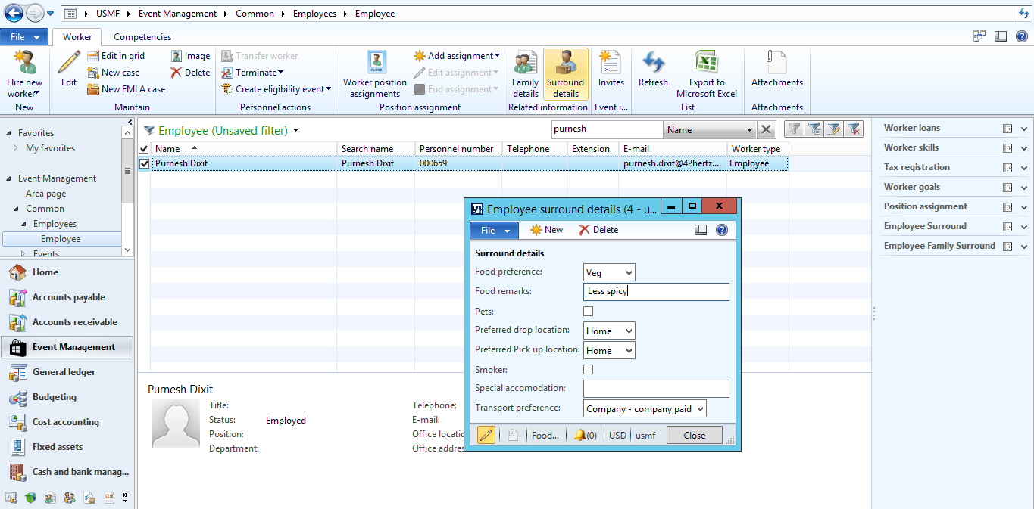

## Employee family details

Similar to employee surround details, here you should enter all the preferences of the employee’s family members so that they can be utilized for sending relevant invitations, generally for family events.

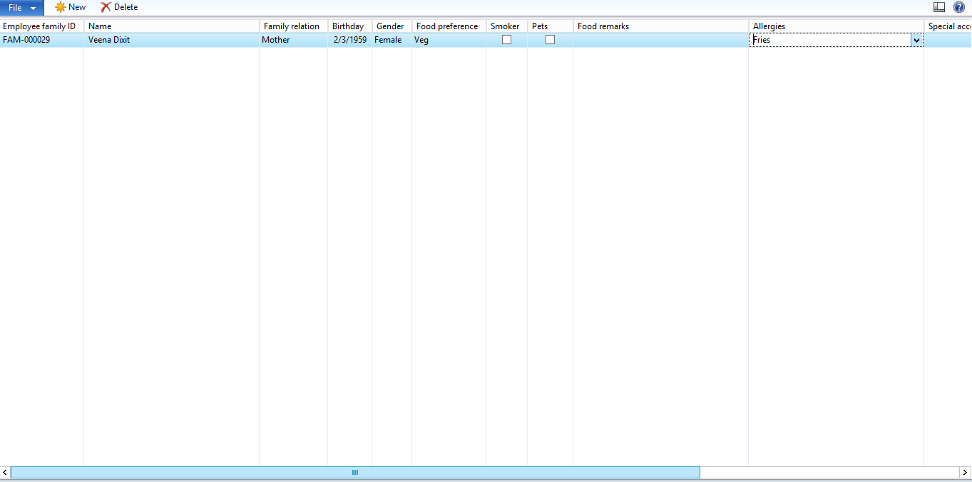

## Roles & Security

Event management by default comes with two roles:-

1. Event manager
2. Employee

### Event manager

This role is specific to the employee who manages all the events and related information like organizing events, promotion, invitation etc. In short, this role will provide access to all the objects of event management module.

### Employee

This is the standard role of employee which is added with few privileges for event management module like checking invitations, event responses etc. This role will have minimum privileges.